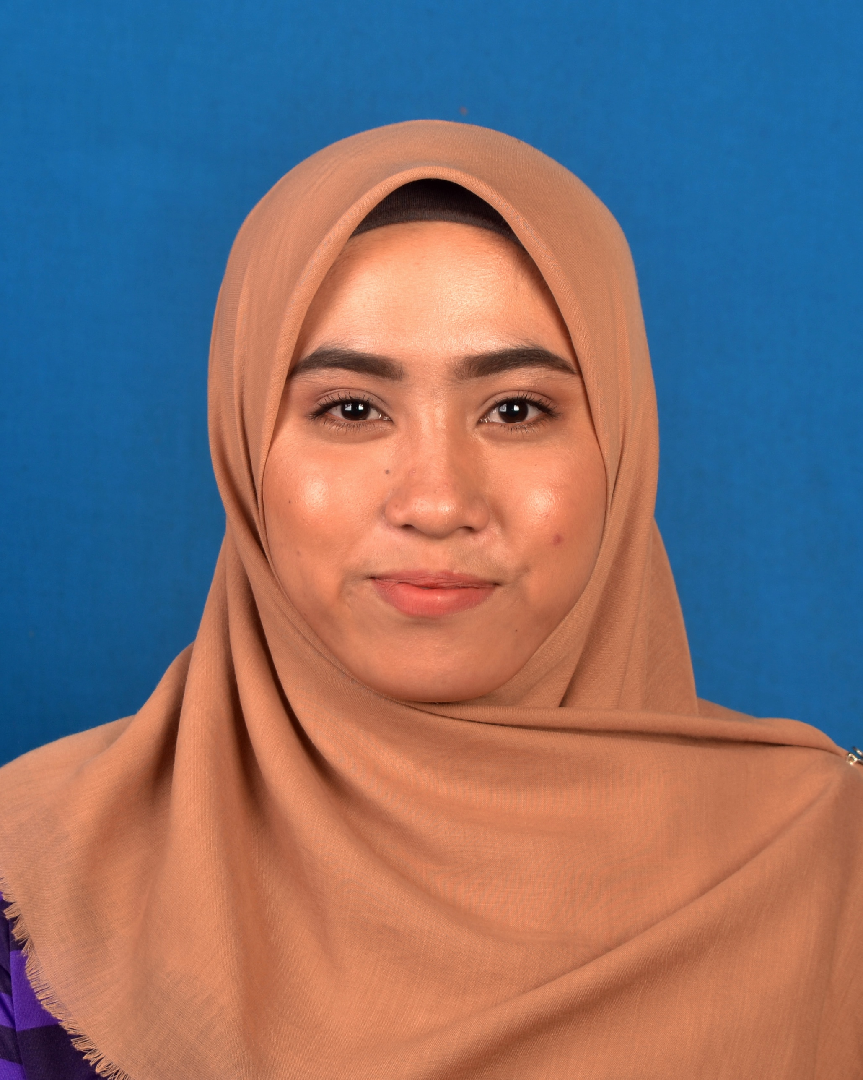

LOT 3379 JALAN TEMBUSU

KAMPUNG MELAYU SUBANG

40150, SHAH ALAM SELANGOR DARUL EHSAN

+60 143140646

fnazurahanuar@gmail.com

fatin nazurah binti anuar (960123-10-6146)

|  |  |
| --- | --- |
| **educational background** | **KOLEJ UNIVERSITI ISLAM ANTARABANGSA SELANGOR (KUIS)**  **DIPLOMA IN HUMAN RESOUCE MANAGEMENT**  Current CGPA: 2.77 GPA: 2.57 (Fifth Semester)  (Expected to graduate on August 2018)   * **SEKOLAH MENENGAH KEBANGSAAN SUBANG (SMKS)**   (2012 – 2013)  SPM Result: 2A-, 1B+,2B,1C,1C+,2D  (2009 – 2011)  PMR Result: 2A,3B,2C1D |
| **LANGUAGES** | Spoken Written   * Bahasa Malaysia Excellent Excellent * English Fair Fair |
| **awards/achievements** | * Representing the school in cross- country event at the MSSD Daerah Petaling Perdana (2013-2014) * Treasures in LATIHAN BINA INSAN SEHARI BERSAMA KANAK-KANAK TADIKA INTAN GENIUS (29 JANUARI 2016) * As Bureau Module for PROGRAM JALINAN UKHWAH BERSAMA ANAK-ANAK YATIM DAN FAKIR MISKIN,LANGKAWI) under subject Training and Development (9-10 JANUARI 2017) |
| **EXTRACURRICULAR ACTIVITIES** | * Participate in PROGRAM KEUSAHAWANAN MAHASISWA ISLAM KUIS (M-STEP) (23 JANUARI 2017) * Participate in PROGRAMME TALK ON PERFORMANCE MANAGEMENT (24 JANUARI 2017) * Participate in *PROGRAM LATIHAN TRANSFORMASI NEGARA (MAHASISWA) ANJURAN BIRO TATANEGARA JABATAN PERDANA MENTERI* (27 MAC-29MAC 2015) * Participate in the Planting with MBSA & UMW at Padang Bola, Jalan U5/18A Seksyen U5,Shah Alam (23 AUGUST 2014) * Committee Members of Taekwondo Club KUIS (Yellow Belt) |
| **skills** | * Microsoft Office (Word, PowerPoint, Excel) * Video Editor (Wonder share) |
| **personal strengths** | * Team oriented and helpful * Flexible, self-discipline and easy-going person * Easily adapt to any kind of environment * Punctual, organized and efficient * Able to work under pressure * Strong work ethic |
|  | PUAN MARHAINI BINTI ABDUL GHANI (Mentor)  HP No: 019-6746 260  Email: marhaini@kuis.edu.my    SIR PANJI HIDAYAT BIN MAZHISHAM (Subject’s Lecturer)  HP No: 011-3269 0952  Email: panjihidayat@kuis.edu.my |